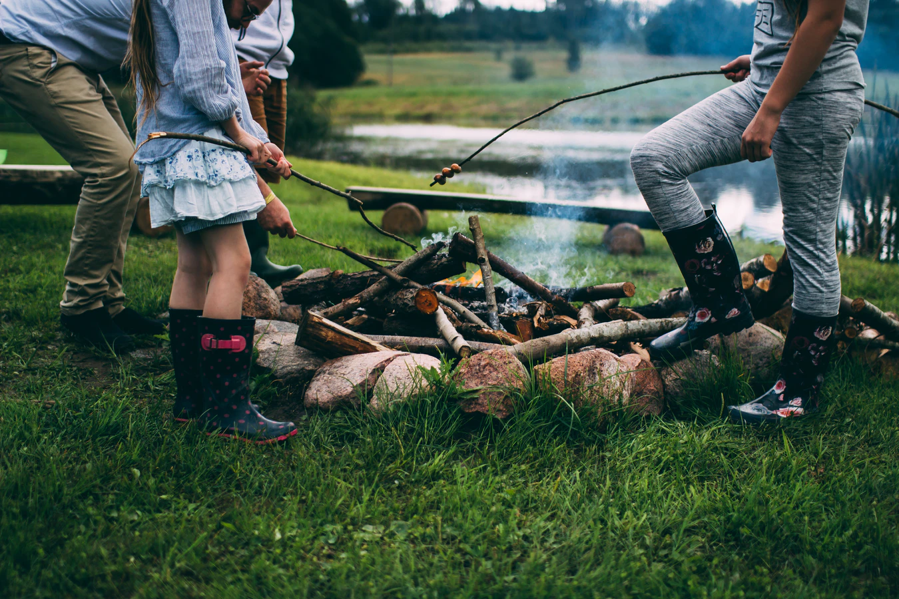
Image via Unsplash

How to Get Your Family on Track and Away From Nature-Deficit Disorder

Even if you’re just hearing about nature-deficit disorder, you’ve probably heard the hubbub about how much time kids are spending indoors. While it might seem innocuous in some ways, so much time inside is actually not good for us at any age — and it can be particularly damaging for kids. Thankfully, there is much moms and dads can do to get everyone on a healthier track.

Get Healthier and Happier in the Great Outdoors

Spending Time Outdoors Will Improve Your Health In 9 Fascinating Ways
Why Kids Need Nature
Why Spending Just Two Hours a Week in Nature Is Good for You
Sleep Camp: How Nature Can Help Us Sleep Better

Outdoor Adventures Begin at Home

How to Camp Under the Stars in Your Own Backyard
Home Science: Backyard Astronomy Basics
How to Build a DIY Fire Pit for Only $60
Backyard Treasure Hunt with Picture Clues

Explore Nature in Your Community

Roscommon County Parks Offer Family-Friendly Fun
Visit Marguerite Gahagan Nature Preserve
Enjoy Roscommon Area Campgrounds
Best Playgrounds Near Roscommon, MI

Outdoor Activities the Whole Family Can Enjoy

How to Thru-Hike with Your Family
How Geocaching Can Get Your Family Outside, Moving, and Having Fun
4 Tips When Mountain Biking with Your Child
Birding 101: Get Started Birding with Kids

Whether you’ve heard about nature-deficit disorder before or not, you’re probably aware if your family needs more time in nature. Getting your family into the great outdoors is important, but thankfully, it’s also easy! Plan some backyard adventures, look for community-based fun, and find outdoor activities that are family-friendly, and you and the kids will be right on track!

